Finding information
Doing research used to mean sitting in a library with loads of books and getting bored. Now there are different ways of learning things that can be very interesting.
There are loads of ways to find information!

You can read newspapers and encyclopedias.
You can use CD-ROMs that show different things using multimedia. Basically it’s more fun because of all sounds , pictures and videos…
There’s lots on the internet too

Most newspapers they have their own websites .In fact lots of businesses and other organisations have
Websites(e.g. Banks, Museums, tourist offices etc …).
Website addresses look like this:
http://www.bbc.co.uk
The proper name is a URL

URL: A URL is the address of website. If you type it into the
“Address” box at the top of the page you and hit “Enter”
You will be taken straight to it.

A really good thing about using the internet for research is:
There is a huge amount of information on the internet.
A really bad thing about using the internet for research is:
There is so much information on it that it’s easy to get lost, you can waste time looking at things that are not really useful.
So not all information are RELIABLE
Information comes from different sort of places, but you can’t always be sure it’s reliable.
Because:
- Anyone can set up their own website
- There are not any rules for what you can and can’t say on your own website.
- This means you can say whatever you want
And we should know :we can’t trust everything that we read in the net.

When you search about something ask these questions:
- Who wrote this?
- What is it saying?
- What can I compare it with?
Search Engines
A web search engine is a software system that is designed to search for information on the World Wide Web. The search results are generally presented in a line of results often referred to as search engine results pages .
Top search engines:
www.ask.com
www.bing .com
www.Duck Duck Go.com www.dogpile.com (meta search engine)
www.yahoo.com
www.webopedia.com
Webopedia is a web site that you can find the meaning of all computer terms and expressions.

"What do the different extensions mean?"
Extensions are categories of Internet domain names.
- .com represents the word "commercial," and is the most widely used extension in the world. Most businesses prefer a .com domain name because it is a highly recognized symbol for having a business presence on the Internet.
- .net represents the word "network," and is most commonly used by Internet service providers, Web-hosting companies or other businesses that are directly involved in the infrastructure of the Internet. Additionally, some businesses choose domain names with a .net extension for their intranet Websites.
- .org represents the word "organization," and is primarily used by non-profits groups or trade associations.
- .biz is used for small business Web sites.
- .info is for credible resource Web sites and signifies a "resource" web site. It's the most popular extension beyond .com, .net and .org.
- .co.uk is the country code for United Kingdom. The .co portion of the extension indicates the domain name is for commercial purposes (similar to a standard .com extension). It is unrestricted and may be registered by anyone, from any country.

Now you search about your topic in your favorite search engines, the search should only take a couple of seconds. The search engine will show you all sites it found.
Each result is called a hit.

It will show the hits in a list like this . 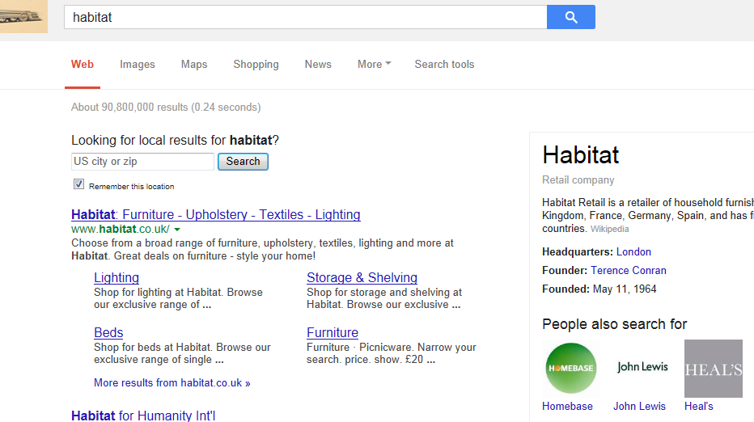

Useful ways to search
- Search engines usually disregard minor words such as "the, to, etc."

- Translation of a language may not be entirely accurate. Keywords may result with a different ranking of web pages.

- Generally, capitalization is not needed.

- Use more word to narrow down your searches. To narrow down searches use several words separated by a space.

- Choose your words carefully. Some words get better result than others. That’s because they are more specific.

- Skimming through results
You need to practice skimming through results. This means trying to look through lists of titles quickly and judging if they look useful or not- you can do this by picking out some key words.

Hyperlink:
You can use hyperlink buttons to surf the net. Most websites have buttons on them that link to other webpages when you click on them. You can use them to jump from one website to another website.
Bookmarking sites:
Typing the whole URL in each time can be tricky. If you get any of it wrong it won’t work.
But you can bookmark the websites that you use the most. So you can get through them more quickly. This adds them to favorite list.
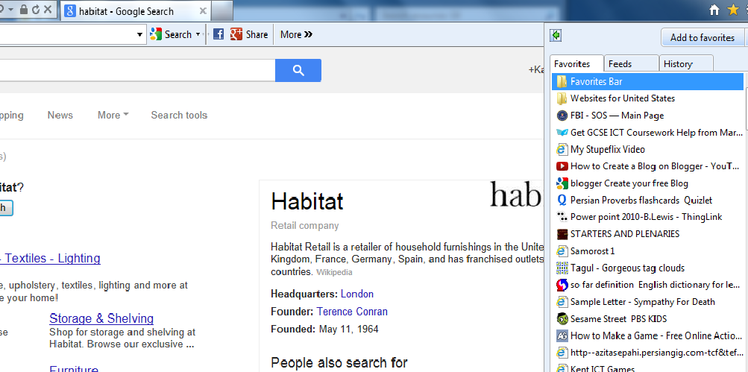
Here’s how you bookmark a website in the net:
- Go to page you want to bookmark.
- Click on “favorites” on the toolbar.
- Click on “add to favorite”
- Then a box will appear with the name of a webpage.
- Choose which folder you want to save it in and click Add.

Grade: 6
Gems Winchester school, Dubai
ICT Department

Read and follow this advice to help you stay safe when using the internet.

Talk to your parents
Speak to your parents about what you will be doing on the Internet. Agree some rules between you about what sites you are allowed to use, what times of the day you can log on and for how long you are allowed to be online.

Never give out your password
No matter who asks, whether it is a stranger in an email or your best friend, never ever give out your passwords.
Once people have your password they can log into your accounts and post as if it were you. You have no control over what they might say and you are responsible, even if it wasn't you that said it.

Don't give out your contact details
On this site, we get emails every day from students who want to add their opinion to the current poll or hot topic.
I am amazed at how many students put their email address, facebook page and even phone number in their message saying 'contact me'. Note: we remove any personal details before the post is placed in the poll or hot topic.
You don't know who is reading things that you post on the internet. Don't make it so easy for strangers to find out who you are and get in touch with you.

Don't download any software without permission
Even if that free game is exactly what you have been after for weeks, don't ever download or install software without checking with your parents first.
Most software is fine and won't cause you any problems. But some sites put up games or things that look interesting so that you will download them. Once you install them, they might have a virus or a key logger which can automatically send details of everything you type to somebody.

Respect people's privacy
Just because your camera might be able to take photographs or videos, you don't have the right to post those pictures or videos onto the internet without permission.
Try to imagine how you would feel if you found out that a video showing you doing something very embarrassing was posted onto the internet and you didn't know how many people had watched it. You would feel humiliated and might be scared of facing people afterwards.
This is bullying - don't be the person who humiliates others.

Use a child safe web browser
Many web browsers offer a child friendly version. This means that sites have been checked beforehand to make sure that they are suitable. You would be far less likely to accidentally come across a website with inappropriate content.

Respect copyright
Imagine you have a piece of homework that is due in for tomorrow. You think that there is no need to panic because you know that you can find a website and just copy and paste what they have written.
That is a bad idea. Firstly, your teacher will know, they can tell when something isn't written in your own words. Secondly, you haven't done yourself any favours. Yes, you got your homework in on time, but did you actually learn anything? Thirdly, and more importantly, the work on the internet wasn't yours to copy, it belonged to the person who had written it. So effectively, you have stolen their work.
Don't just copy and paste work from the internet. Research, read, understand and then write in your own words.

Use the internet safely and responsibly
While you are going about your everyday life, you know what is right and wrong, what you should and shouldn't do. Well the same rules apply to the internet.
Don't say mean or untrue things about other people, don't tell lies, don't try to embarrass or trick anyone.

ICT teacher : Ms.Maryam

